# Design of a 500 L liquid helium dewar

*A report submitted*

*by*

**Mr. AAMIR HAIDER**

Under the guidance of

**Ms. BHUMIKA JOSHI**



**INOX INDIA LIMITED**

**VADODARA**

2023

**Table of contents**

**1. INTRODUCTION …………………………………………………………... 3**

# 2. OBJECTIVES ..…………………...……………………………...... 4

**3. DESIGN**

**a) Mechanical design ...…………………………………………………4**

**b) Thermal design………………………………………………...…….18**

**4. RESULTS ………………………………………………………………….…21**

**5. LIST OF REFERENCES….……………………………………………........22**

**6. ANNEXURE : Drawing for the inner and outer vessel of the dewar…… 23**

**List of Figure**

Figure 1 : Liquid helium dewar schematic 3

Figure 2 : Tori-spherical head 4

Figure 3 : M/EI vs x diagram 8

Figure 4 : Apparent thermal conductivity vs Pressure 19

# List of Table

Table 1 : Dimensions of Tori-spherical head……………..............................……..………….4

Table 2 : Inner vessel dimensions 5

Table 3 6

Table 4 7

Table 5 7

Table 6 : Deflection of inner vessel 8

Table 7 : FOS calculation under different load condition 9

Table 8 : Nozzle reinforcement of inner vessel 10

Table 9 : Lower size head dimensions 11

Table 10 : Head dimension of outer vessel 12

Table 11 : Internal Pressure check of cylindrical portion of Outer Vessel 13

Table 12 : External pressure check for cylindrical portion of outer vessel 14

Table 13 : Pressure check of head 14

Table 14 : Pressure check of neck tube 15

Table 15 : Thickness calculation of tori-spherical head 16

Table 16 : Nozzle reinforcement calculation of outer vessel 17

Table 17 : Thermal design input variables 18

Table 18 : Radiation heat-load to shields 20

Table 19 : Radiation heat load on neck 20

**1 . INTRODUCTION**

A liquid helium dewar is a double-walled container with the space between the two vessels filled with an insulation and the gas evacuated from the space. Liquid helium is stored in the inner vessel. Annular space between the outer and inner vessels is maintained under high vacuum due to initial evacuation and cryo-pumping at cold conditions. The cryo-pumping is achieved through the use of activated charcoal placed in contact with the inner vessel. Multilayer super insulation (MLI) and thermal shields are used between the inner and outer vessels to lower the heat load due to radiation and free molecular conduction. Liquid helium dewars are used for storage and distribution of liquid helium. These dewars have low heat in-leak for long term liquid helium hold-up.

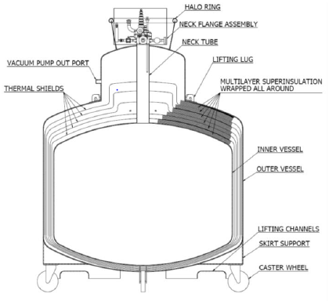

**Figure 1 : Liquid helium dewar schematic**

**2. OBJECTIVES**

 To design a liquid helium dewar of 500 L capacity, capable of being transported under fully loaded condition with minimum heat in leak.

**3. DESIGN**

1. **Mechanical Design**

Mechanical design consists of designing the inner and outer vessel based on the design pressure after assuming sufficient geometry parameters as inputs and checking whether the provided material can sustain the design pressure.

**1. Inner Vessel Design:**

* 1. **Tori-spherical head**

The green cell dimensions were taken as inputs to the tori-spherical head and the other parameters determined based on the ASME code for flanged and dished head.

Inside corner radius =>0.06*Inside Diameter

Radius of dish= head outside diameter

Nominal diameter = outside diameter

V= 0.000049*Di3, Di= inside dia in inches, V = volume in cubic feet

Blank dia= OD + OD/42 + 2*sf+2/3 *icr ; for gages under 1 in.

Blank dia= OD + OD/24 + 2*sf+2/3 *icr + t; for gages >= 1 in.

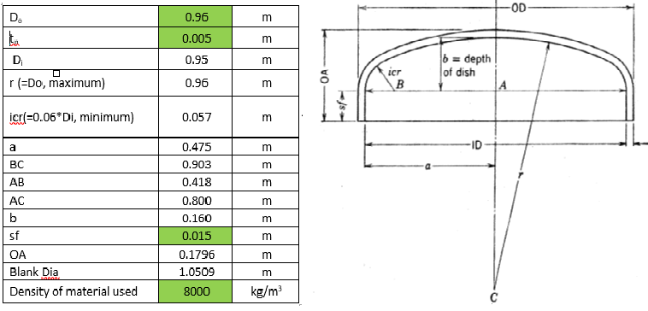

**Table 1 : Dimensions of Tori-spherical head** **Figure 2 : Tori-spherical head**

|  |  |  |
| --- | --- | --- |
| Weight of Head | 34.693 | kg |
| Inside volume of Head (Without straight length) | 0.073 | m3 |
| Inside volume of Head (With straight length) | 0.083 | m3 |
| Blank Surface Area One Side | 0.867 | m2 |

The surface area of the tori-spherical head without straight flank was determined based on the following formula.

SA = πR2 ( 1 + (L/R)2 (2 – L/R))

Where L is the depth of the head and R is the outside radius of the head.

* 1. **Straight portion of inner vessel**

The green cell values were taken as input variables and the thickness of internal pressure vessel was checked for external pressure using ASME Section VIII division 1 sub-section UG-27.

**Table 2 : Inner vessel dimensions**

|  |  |  |  |  |
| --- | --- | --- | --- | --- |
| **INNER VESSEL DESIGN** | | | | |
| Nominal Volume of Dewar | 0.5 | m3 |  |  |
| Ullage Space | 0.05 | m3 |  |  |
| Total Volume of Dewar | 0.55 | m3 | Total Volume of Dewar (Actual) | 0.557951 |
| Volume of 2 no.s torispherical heads | 0.166 | m3 |  |  |
| Volume of cylindrical portion | 0.384 | m3 | Volume of cylindrical portion (Actual) | 0.391495 |
| Do | 0.96 | m |  |  |
| tn | 0.004 | m |  |  |
| Di | 0.952 | m |  |  |
| L | 0.53883 | m | Lactual | 0.55 |
| Material | SS 304 L |  |  |  |
| Allowable stress value  (ASME Sec II, Part D) | 115000000 | N/m2 |  |  |
| Pi (Design Pr.) | 3.00E+05 | N/m2 |  |  |
| Joint Efficiency (1 for 100% radiography, 0.85 for without radiography) | 1 |  |  |  |
| tr(=Pi*Ro/(SE+0.4Pi) | 1.25E-03 | m |  |  |
| Material volume (Cylindrical) | 0.0066074 | m3 |  |  |
| Weight of cylinder | 52.8591814 | kg |  |  |
| Weight of inner vessel (Cylinder + two heads) | 122.244443 | kg |  |  |
| Height of Inner Vessel | 0.90914398 | m |  |  |
| Surface Area of Cylindrical Portion(Outer) | 1.65876092 | m2 |  |  |
| Total Outer Surface Area of Inner Vessel | 3.47888614 | m2 |  |  |

**1.3 Thickness check under external pressure**

The thickness of internal pressure vessel was checked for external pressure using ASME Section VIII division 1 sub-section UG-28. The factors A and B were calculated using the material chart in Section II, Part D using figure -G and figure -HA3 respectively.

The assumed thickness was found to be appropriate for the pressure.

**Table 3 : Inner vessel thickness check under external pressure**

|  |  |  |  |  |
| --- | --- | --- | --- | --- |
| **CALCULATION OF THICKNESS OF THE CYLINDRICAL PORTION OF INNER VESSEL UNDER EXTERNAL PRESSURE:** | | | | |
| Assumed thickness of the cylindrical portion of inner vessel | 0.004 | m | 0.0035 | 0.003 |
| Length of cylindrical portion of inner vessel (UG 28.1) | 0.68971466 | m |  |  |
| Outside diameter of the cylindrical portion of inner vessel | 0.96 | m |  |  |
| Inside diameter of the cylindrical portion of inner vessel | 0.952 | m |  |  |
| L/Do | 0.71845277 |  | 0.718453 |  |
| Do/t | 240 |  | 274.2857 | 320 |
| Factor A (From ASME BPVC Section II, Part D) | 0.00053 |  | 0.000427 | 0.000341 |
| Factor B (From ASME BPVC Section II, Part D) | 51.2045 |  | 41.53942 | 33.21748 |
| Allowable external pressure Pa(=4B/3(Do/t) | 0.284 | MPa | 0.201928 | 0.138406 |
| Allowable external pressure Pa(=4B/3(Do/t) | 2.845 | bar | 2.019277 | 1.384062 |

**1.4 Thickness of tori-spherical head under internal pressure**

The thickness of tori-spherical head was checked for pressure on concave and convex side using ASME Section VIII division 1 sub-section UG-32 & UG-33 respectively. The assumed thickness of 5mm was found to be appropriate for the design pressure and a reduced thickness up-to 3mm may be tolerated as the forming allowance.

**Table 4 : Inner vessel pressure check under internal pressure**

|  |  |  |
| --- | --- | --- |
| **THICKNESS OF TORISPHERICAL HEAD UNDER INTERNAL PRESSURE:** | | |
| Internal pressure (Pressure on concave side) | 3.0E+05 | Pa (N/m2) |
| r ( Dish radius) | 0.96 | m |
| tr (=0.885Pi*r/(SE-0.1Pi) | 0.00222 | m |
| tn | 0.005 | m |
| **THICKNESS OF TORISPHERICAL HEAD EXTERNAL PRESSURE:** |  |  |
| th | 0.0045 | m |
| (r+th)/th | 214.3333333 |  |
| Factor A (=0.125/((r+th)/th) | 0.000583204 |  |
| Factor B | 52.67337884 |  |
| Pa (=B/((r+th)/th) | 0.245754489 | MPa |
| Pa (=B/((r+th)/th) | 2.457544891 | bar |

**1.5 Neck tube design**

A pipe of **90** mm nominal diameter was selected and the thickness of neck tube was checked for internal & external pressure using ASME Section VIII division 1 sub-section UG-27 & UG- 28 respectively. The thickness was found to be suitable for the design pressure.

**Table 5**

|  |  |  |
| --- | --- | --- |
| **NECK TUBE DESIGN INTERNAL PRESSURE** | | |
| Do | 0.1016 | m |
| tn | 0.00305 | m |
| Di | 0.0955 | m |
| L | 0.48 | m |
| Material | SS 304 L |  |
| Allowable stress value ( ASME Sec II, Part D) | 115000000 | N/m2 |
| Pi(Design Pr.) | 3.00E+05 | N/m2 |
| Joint Efficiency (1 for 100% radiography, 0.85 for without radiography) | 0.85 |  |
| tr(=Pi*Ro/(SE+0.4Pi) | 1.56E-04 |  |
| **NECK TUBE DESIGN EXTERNAL PRESSURE** | | |
| L/Do | 4.724409449 |  |
| Do/t | 33.31147541 |  |
| Factor A | 0.0013517 |  |
| Factor B | 61.85 |  |
| Allowable external pressure Pa(=4B/3(Do/t) | 2.47562336 | MPa |
| Allowable external pressure Pa(=4B/3(Do/t) | 24.7562336 | bar |

**1.6 Stresses in the neck**

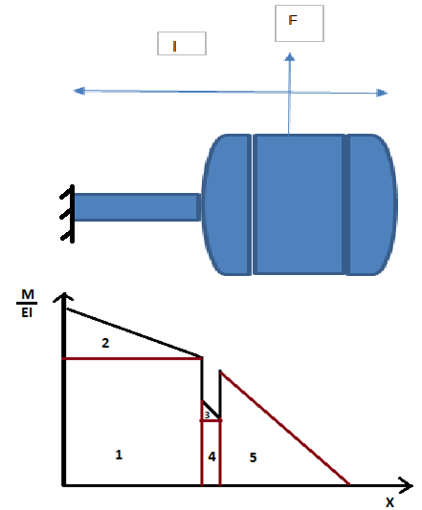

**Figure 3 : M/EI vs x diagram**

 Deflection calculation

Deflection of the inner vessel is calculated based

by assuming the inner vessel to be a cantilever beam fixed at the neck end. Since the inner vessel has varying cross-section along its axis so Moment-area method was selected for finding the deflection in the beam. The diagram is divided into five portions and the total deflection of the free end is found by the sum of the deflection by each portion. Also it has been verified considering the beam to of uniform neck cross-section and using the standard result.

**Table 6 : Deflection of inner vessel**

|  |  |  |
| --- | --- | --- |
| Neck outside diameter | 0.1016 | m |
| Neck inside diameter | 0.0955 | m |
| Cross sectional area of neck | 0.00094429 | m2 |
| Moment of inertia of neck w.r.t. NA | 1.1475E-06 | m4 |
| Distance of outer fiber from NA. | 0.0508 | m |
| Modulus of Elasticity | 2E+11 | Pa |
| **Total force acting at the CG of inner vessel (lateral force due to 1.5 g load)** | 1798.82698 | **N** |
| Approximate length of CG from Neck weld (a) | 0.93457199 | m |
| Total height of Inner Vessel (l) | 1.38914398 | m |
| Max Deflection ( =Fa2(3l-a)/(6EI)) ( simplified formulae) | 0.00368872 | m |
| Deflection at CG( =Fa3/(3EI)) ( simplified formulae) | 0.00213271 | m |
| Bending Stress (My/I) | 74425279.5 | Pa |
| Bending Stress (My/I) | 744.252795 | bar |
| Moment of Inertia of Top and bottom head taken as a flat head | 0.0416922 | m4 |
| Moment of Inertia of Inner vessel cylindrical vessel | 0.00137246 | m4 |
| M/EI at the start of neck tube (fixed end) | 0.00732532 | m-1 |
| M/EI at the end of neck tube | 0.00356301 | m-1 |
| M/EI at the start of top head | 9.8063E-08 | m-1 |
| M/EI at the end of top head | 9.6985E-08 | m-1 |
| M/EI at the start of cylinder | 2.9462E-06 | m-1 |
| M/EI at CG | 0 | m-1 |
| Deflection of free end, part1 | 0.00196532 | m |
| Deflection of free end, part2 | 0.00110986 | m |
| Deflection of free end, part3 | 4.3965E-10 | m |
| Deflection of free end, part4 | 2.4471E-12 | m |
| Deflection of free end, part5 | 1.9849E-07 | m |
| Deflection of free end total | 0.00307538 | m |

 Determining the factor of safety (FOS) for different load conditions

Factor of safety has been determined in the fully loaded condition and is found to be greater than one. Hence our design is safe.

**Table 7 : FOS calculation under different load condition**

|  |  |  |
| --- | --- | --- |
| Minimum Sy for SS304L ( ASME Sec II, Part D) for Pb | 170000000 | N/m2 |
| Allowable stress value ( ASME Sec II, Part D) for Pb | 153000000 | N/m2 |
| Allowable stress value ( ASME Sec II, Part D) for Pb | 1530 | bar |
| Actual Sy as per material testing of tube | 3400 | bar |
| Actual 0.9*Sy as per material testing of tube | 3060 | bar |
| FOS | 2.05575311 |  |
| Mass of Copper shields | 30 | kg |
| **Total force acting at the CG of inner vessel (lateral force due to 1.5 g load) Including mass of Cu shields** | 2240.27698 | N |
| Bending Stress (My/I) Including mass of Copper Shields | 92689982.1 | Pa |
| Bending Stress (My/I) Including mass of Copper Shields | 926.899821 | bar |
| FOS Including Copper shields | 1.65066382 |  |
| Liquid Helium Density | 125 | kg/m3 |
| Mass of Liquid Helium | 62.5 | kg |
| **Total force acting at the CG of inner vessel (lateral force due to 1.5 g load) Including mass of Cu shields and Lhe** | 3159.96448 | N |
| Bending Stress (My/I) Including mass of Copper Shields | 130741446 | Pa |
| Bending Stress (My/I) Including mass of Copper Shields | 1307.41446 | bar |
| FOS Including Copper shields and Liquid Helium | 1.17024865 |  |

**1.7 Reinforcement calculation**

The reinforcement calculation for the nozzle opening of the neck tube has done in accordance with ASME Section VIII division 1 subsection UG-37 and the need for reinforcement has been found. The sufficient reinforcement was added in accordance with the limits to reinforcement as defined in subsection UG-40 of ASME Section VIII division 1.

**Table 8 : Nozzle reinforcement of inner vessel**

|  |  |  |
| --- | --- | --- |
| **REINFORCEMENT CALCULATION ON THE OPENING ON TOP TORISPHERICAL HEAD OF INNER VESSEL:** | | |
| Opening diameter for neck tube | 0.1016 | m |
| Opening radius for neck tube | 0.0508 | m |
| tr (Minimum required thickness of torispherical head) | 0.0028 | m |
| trn (Required nozzle thickness) | 1.56E-04 | m |
| tn (Actual nozzle thickness) | 0.00305 | m |
| t(Actual tickness of torispherical head) | 0.0045 | m |
| d | 0.0955 | m |
| F | 1 |  |
| fr1 (=Sn/Sv) | 1 |  |
| **A (=dtrhF+2tntrF(1-fr1)** | **0.0002674** | **m2** |
| E1 | 1 |  |
| A1(=max(d(E1t-Ftr)-2tn(E1t-Ftr)(1-fr1)), 2(t+tn)(E1t-Ftr)-2tn(E1t-Ftr)(1-fr1)) | 0.00016235 | m2 |
| fr2 (=Sn/Sv) | 1 |  |
| A2(=min(5(tn-trn)*fr2*t, 5(tn-trn)fr2tn) | 4.41378E-05 | m2 |
| Weld leg outer | 0.002 | m |
| Weld leg inner | 0.002 | m |
| A41 | 0.000004 | m2 |
| A42 | 0.000004 | m2 |
| A43 | 0.000004 | m2 |
| **Total available reinforcement** | **0.000214488** | **m2** |
| As total available area is less than required area hence reinforcement is required. |  |  |
| **Required reinforcement** | **5.29122E-05** | **m2** |
| fr4 (=Sp/Sv) | 1 |  |
| Dp | 0.187 |  |
| te | 0.002 | m |
| A5=(Dp-d-2tn)tefr4 | 0.0001708 |  |
| **Total area available with reinforcement** | **0.000385288** | **m2** |

1. **Outer vessel design:**

**2.1 Head dimension of lower size head**

The green cell dimensions were taken as inputs to the tori-spherical head and the other parameters determined based on the ASME code for flanged and dished head.

Inside corner radius =>0.06*Inside Diameter

Radius of dish= head outside diameter

Nominal diameter = outside diameter

V= 0.000049*Di3 , Di= inside dia in inches, V = volume in cubic feet

Blank dia= OD + OD/42 + 2*sf+2/3 *icr ; for gages under 1 in.

Blank dia= OD + OD/24 + 2*sf+2/3 *icr + t; for gages >= 1 in.

**Table 9 : Lower size head dimensions**

|  |  |  |
| --- | --- | --- |
| **DIMENSIONS OF TORISPHERICAL HEAD** | | |
| Do | 0.6 | m |
| tn | 0.005 | m |
| Di | 0.59 | m |
| r (=Do, maximum) | 0.6 | m |
| icr(=0.06*Di,  minimum) | 0.044 | m |
| a | 0.295 | m |
| BC | 0.556 | m |
| AB | 0.251 | m |
| AC | 0.49612 | m |
| b | 0.10388 | m |
| sf | 0.015 | m |
| OA | 0.12388 |  |
| Blank Diameter | 0.673619 |  |
| Density of material used | 8000 | kg/m3 |
| Weight of Head | 14.25537 |  |
| Inside volume of Head (Without straight length) | 0.01739 | m3 |
| Inside volume of Head (With straight length) | 0.021491 | m3 |

**2.2 Head dimension of outer vessel head**

The green cell dimensions were taken as inputs to the tori-spherical head and the other parameters determined based on the ASME code for flanged and dished head.

Inside corner radius =>0.06*Inside Diameter

Radius of dish= head outside diameter

Nominal diameter = outside diameter

V= 0.000049*Di3 , Di= inside dia in inches, V = volume in cubic feet

Blank dia= OD + OD/42 + 2*sf+2/3 *icr ; for gages under 1 in.

Blank dia= OD + OD/24 + 2*sf+2/3 *icr + t; for gages >= 1 in.

**Table 10 : Head dimension of outer vessel**

|  |  |  |
| --- | --- | --- |
| **Dimension of Torispherical head** | | |
| Do | 1.42 | m |
| tn | 0.005 | m |
| Di | 1.41 | m |
| r (=Do, maximum) | 1.412 | m |
| icr(=0.06*Di, minimum) | 0.0846 | m |
| a | 0.705 | m |
| BC | 1.3274 | m |
| AB | 0.6204 | m |
| AC | 1.173496741 | m |
| b | 0.238503259 | m |
| sf | 0.015 | m |
| OA | 0.258503259 | m |
| Blank Diameter | 1.540209524 | m |
| Density of material used | 8000 | kg/m3 |
| Weight of Head | 74.5262865 | kg/m3 |
| Inside volume of Head (Without straight length) | 0.237354329 | m3 |
| Inside volume of Head (With straight length) | 0.26077608 | m3 |

**2.3 Straight length of outer vessel**

The green cell values were taken as input variables and the thickness of internal pressure

vessel was checked for external pressure using ASME Section VIII division 1 sub-section

UG-27.

**Table 11 : Internal Pressure check of cylindrical portion of Outer Vessel**

|  |  |  |
| --- | --- | --- |
| Do | 1.42 | m |
| tn | 0.004 | m |
| Di | 1.412 | m |
| L | 0.725 | m |
| Material | SS 304 L |  |
| Allowable stress value ( ASME Sec II, Part D) | 1.15E+08 | N/m2 |
| Pi(Design Pr.) | 3.00E+05 | N/m2 |
| Joint Efficiency (1 for 100% radiography, 0.85 for without radiographY) | 0.85 |  |
| tr(=Pi*Ro/(SE+0.4Pi) | 2.18E-03 | m |
| Material volume | 0.012901 | m3 |
| Weight of cylinder | 103.2051 | kg |
| Weight of inner vessel (Cylinder + two heads) | 252.2577 | kg |

**2.4 Thickness check under external pressure**

The thickness of internal pressure vessel was checked for external pressure using ASME Section VIII division 1 sub-section UG-28. The factors A and B were calculated using the material chart in Section II, Part D using figure -G and figure -HA3 respectively.

The assumed thickness was found to be appropriate for the pressure.

|  |  |  |
| --- | --- | --- |
| **CALCULATION OF THICKNESS OF THE CYLINDRICAL PORTION OF OUTER VESSEL UNDER EXTERNAL PRESSURE:** | | |
| Assumed thickness of the cylindrical portion of inner vessel | 0.0038 | m |  |
| Length of cylindrical portion of inner vessel | 0.917335506 | m |  |
| Outside diameter of the cylindrical portion of inner vessel | 1.42 | m |  |
| Inside diameter of the cylindrical portion of inner vessel | 1.412 | m |  |
| L/Do | 0.64601092 |  |  |
| Do/t | 373.6842105 |  |  |
| Factor A (From ASME BPVC Section II, Part D) | 0.000304335 |  |  |
| Factor B (From ASME BPVC Section II, Part D) | 29.64829706 |  |  |
| Allowable external pressure Pa(=4B/3(Do/t) | 0.105787351 | MPa |  |
| Allowable external pressure Pa(=4B/3(Do/t) | 1.05787351 | Bar |  |

**Table 12 : External pressure check for cylindrical portion of outer vessel**

**2.5 Thickness of tori-spherical head under internal and external pressure**

The thickness of tori-spherical head was checked for pressure on concave and convex side using ASME Section VIII division 1 sub-section UG-32 & UG-33 respectively. The assumed thickness of 5 mm was found to be appropriate for the design pressure and a reduced thickness up-to 4.5 mm may be tolerated as the forming allowance.

**Table 13 : Pressure check of head**

|  |  |  |  |  |
| --- | --- | --- | --- | --- |
| **THICKNESS OF TORISPHERICAL HEAD UNDER INTERNAL PRESSURE:** | | | | |
| Internal pressure (Pressure on concave side) | 3.00E+05 | N/m2 |  |  |
| r ( Dish radius) | 1.412 | m |  |  |
| tr (=0.885Pi*r/(SE-0.1pi) | 3.84E-03 | m |  |  |
| tn | 0.005 | m |  |  |
| **THICKNESS OF TORISPHERICAL HEAD EXTERNAL PRESSURE:** | | | | |
| th | 0.0045 | m | 0.004 | m |
| (r+th)/th | 314.7778 |  | 354 |  |
| Factor A (=0.125/((r+th)/th) | 0.000397 |  | 0.000353 |  |
| Factor B | 38.668 |  | 34.385 |  |
| Pa (=B/((r+th)/th) | 0.122842 | MPa | 0.097133 | MPa |
| Pa (=B/((r+th)/th) | 1.228422 | bar | 0.971328 | bar |

**2.6 Neck tube design**

A sheet of 4 mm thickness was selected for neck tube and checked for internal & external pressure using ASME Section VIII division 1 sub-section UG-27 & UG- 28 respectively. The thickness was found to be suitable for the design pressure.

**Table 14 : Pressure check of neck tube**

|  |  |  |  |
| --- | --- | --- | --- |
| **NECK TUBE DESIGN INTERNAL PRESSURE** | | | |
| Do | 0.6 | m |  |
| tn | 0.004 | m | 0.002 |
| Di | 0.592 | m |  |
| L | 0.283 | m |  |
| Material | SS304 |  |  |
| Allowable stress value ( ASME Sec II, Part D) | 115000000 | N/m2 |  |
| Pi(Design Pr.) | 3.00E+05 | N/m2 |  |
| Joint Efficiency (1 for 100% radiography, 0.85 for without radiographY) | 0.85 |  |  |
| tr(=Pi*Ro/(SE+0.4Pi) | 9.20E-04 | m |  |
| **NECK TUBE DESIGN EXTERNAL PRESSURE** | | | |
| L/Do | 0.4716667 |  | 0.471667 |
| Do/t | 150 |  | 300 |
| Factor A | 0.0016927 |  | 0.000583 |
| Factor B | 65.9291 |  | 52.6676 |
| Allowable external pressure Pa(=4B/3(Do/t) | 0.5860364 | Mpa | 0.234078 |
| Allowable external pressure Pa(=4B/3(Do/t) | 5.8603644 | bar | 2.340782 |
|  |  |  |  |
|  |  |  |  |
| Density of material used | 8000 | kg/m3 |  |
| Material volume | 0.0021195 | m3 |  |
| Weight of cylinder | 16.956357 | kg |  |
| Weight of inner vessel (Cylinder + two heads) | 166.00893 | kg |  |

**2.7 Pressure check for lower size head**

The thickness of tori-spherical head was checked for pressure on concave and convex side using ASME Section VIII division 1 sub-section UG-32 & UG-33 respectively. The assumed thickness of 5 mm was found to be appropriate for the design pressure and a reduced thickness up-to 2 mm may be tolerated as the forming allowance.

**Table 15 : Thickness calculation of tori-spherical head**

|  |  |  |  |
| --- | --- | --- | --- |
| **THICKNESS OF TORISPHERICAL HEAD UNDER INTERNAL PRESSURE:** | | | |
| Internal pressure (Pressure on concave side) | 3.00E+05 | N/m2 |  |
| r ( Dish radius) | 0.6 | m |  |
| tr (=0.885Pi*r/(SE-0.1Pi) | 1.63E-03 | m |  |
| tn | 0.005 | m |  |
| **THICKNESS OF TORISPHERICAL HEAD EXTERNAL PRESSURE:** | | | |
| th | 0.0045 | m | 0.002 |
| (r+th)/th | 134.3333 |  | 301 |
| Factor A (=0.125/((r+th)/th) | 0.000931 |  | 0.000415 |
| Factor B | 58.7826 |  | 40.3227 |
| Pa (=B/((r+th)/th) | 0.437588 | MPa | 0.133962 |
| Pa (=B/((r+th)/th) | 4.375876 | bar | 1.339625 |

**2.8 Reinforcement calculation**

The reinforcement calculation for the nozzle opening of the neck tube has done in accordance with ASME Section VIII division 1 subsection UG-37 and the need for reinforcement has been found. The sufficient reinforcement was added in accordance with the limits to reinforcement as defined in subsection UG-40 of ASME Section VIII division 1.

**Table 16 : Nozzle reinforcement calculation of outer vessel**

|  |  |  |
| --- | --- | --- |
| **REINFORCEMENT CALCULATION ON THE OPENING ON TOP TORISPHERICAL HEAD OF OUTER VESSEL:** | | |
| Opening diameter for neck tube | 0.6 | m |
| Opening radius for neck tube | 0.3 | m |
| tr (Minimum required thickness of tori-spherical head) | 3.84E-03 | m |
| trn (Required nozzle thickness) | 9.20E-04 | m |
| tn (Actual nozzle thickness) | 0.004 | m |
| t(Actual thickness of tori-spherical head) | 0.0045 | m |
| d | 0.592 | m |
| F | 1 |  |
| fr1 (=Sn/Sv) | 1 |  |
| A (=dtrF+2tntrF(1-fr1) | 0.002271106 | m2 |
| E1 | 1 |  |
| A1(=max(d(E1t-Ftr)-2tn(E1t-Ftr)(1-fr1)), 2(t+tn)(E1t-Ftr)-2tn(E1t-Ftr)(1-fr1)) | 0.000392894 | m2 |
| fr2 (=Sn/Sv) | 1 |  |
| A2(=min(5(tn-trn)*fr2*t, 5(tn-trn)fr2tn) | 6.16083E-05 | m2 |
| Weld leg outer | 0.004 | m |
| Weld leg inner | 0 | m |
| A41 | 0.000016 | m2 |
| A42 | 0 | m2 |
| Total available reinforcement | 0.000470502 | m2 |
| As total availabele area is less than required area hence reinforcement is required. |  |  |
| Required reinforcement | 0.001800604 | m2 |
| fr4 (=Sp/Sv) | 1 |  |
| Dp | 1.176 | m |
| te | 0.004 | m |
| A5=(Dp-d-2tn)tefr4 | 0.002304 | m2 |
| Total area available with reinforcement | 0.002774502 | m2 |

1. **Thermal design**

Due to low latent heat of vaporisation of liquid helium, it becomes increasingly important to minimize the heat-in leaks through various modes of heat transfer. Thus the aim of thermal design is to minimize the heat in-leak through optimization of input variables like shield position, insulation thickness and other design features.

The insulation system consists of multi layered insulation layers interspaced with copper shields. The copper shield makes use of the vapour enthalpy of the cold helium vapour to reduce radiation heat load. A G-10 guide tube is used to increase the heat transfer coefficient of the flowing vapour resulting in more utilization of the cold of helium vapour.

Heat in-leak evaluation is done using finite difference method (FDM) by discretization of Dewar neck and helium vapour into smaller elements and solving the energy balance equations subjected to the appropriate boundary conditions. Similarly, optimization of the thermal shields positions and required number of radiation shields is done by solving energy balance at each shield to neck junction.

**The inputs to the thermal design are as follows**

**Table 17 : Thermal design input variables**

|  |  |  |  |  |  |
| --- | --- | --- | --- | --- | --- |
| Inner Diameter of Neck, in mm | 95.5 |  |  | Shield Positions, from liq. Level, in mm | No. of layers between Shield and container |
| Outer Diameter of Neck, in mm | 101.6 | Shield | 1 | 30 | 10 |
| Neck height, mm | 480 | Shield | 2 | 60 | 10 |
| No. of shields, n (Max. 6) | 5 | Shield | 3 | 90 | 10 |
| Nominal Volume of Dewar, L | 500 | Shield | 4 | 120 | 10 |
| Support and other loads, % per day | 0.1 | Shield | 5 | 240 | 20 |
| No. of elements in the neck | 480 | Shield | 6 | 480 | 40 |

The MLI selected was Lydall 1303B having a layer density of 3.6 layers/mm. The apparent thermal conductivity of which was found at the desired temperatures using the curve generated in MATLAB by assuming the vacuum to be constant at 10-5 Torr and hence ka becomes a function of temperature. The data points for the curve generation was taken from the apparent thermal conductivity curve provided by Lydall which is attached below for reference.

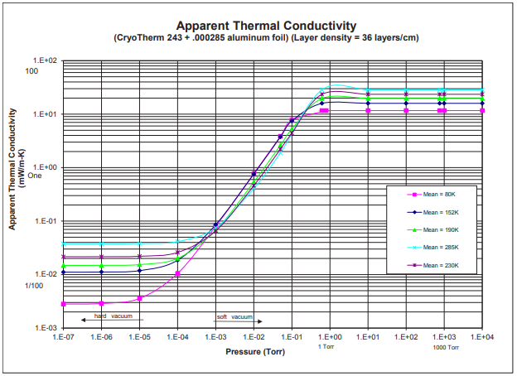

**Figure 4 : Apparent thermal conductivity vs Pressure**

The generated equation is as follows : **ka = (0.0005x2 – 0.0279x + 3.1192) x 10-5**

where x is temperature in Kelvin and ka is in W/m-K.

The average surface area of the shields has been found assuming linear variation of area along neck length and calculating the area based on their position along the neck.

|  |  |  |
| --- | --- | --- |
| **Average Surface Area(SA) of shields** | | |
| Axial distance between outer and inner vessel | 0.14992 | m |
| SA/L =(SA_outer - SA_inner)/L_axial | 8.02806 | m |
| SA_1 | 3.7197 | m2 |
| SA_2 | 3.96054 | m2 |
| SA_3 | 4.68307 | m2 |
| SA_4 | 5.28517 | m2 |
| SA_5 | 5.807 | m2 |
| SA_6 | 7.33233 | m2 |
| SA_avg_shield | 5.1313 | m2 |

**Based on the above inputs the radiation heat loads have been calculated**

**Table 18 : Radiation heat-load to shields**

|  |  |  |  |  |  |
| --- | --- | --- | --- | --- | --- |
| No of layers in neck | Superinsulation Thickness, mm | Apparent Thermal Conductivity, ka, W/(mK) | Heat flux W/(m2K) | Heat Flux, W/K | Heat Loads, Shields to Shields |
| 10 | 2.7778 | 8.32E-06 | 3.00E-03 | 1.54E-02 | 0.0892 |
| 10 | 2.7778 | 8.31E-06 | 2.99E-03 | 1.54E-02 | 0.1075 |
| 10 | 2.7778 | 1.44E-05 | 5.20E-03 | 2.67E-02 | 0.6139 |
| 10 | 2.7778 | 2.66E-05 | 9.58E-03 | 4.92E-02 | 1.7212 |
| 20 | 5.5556 | 4.24E-05 | 7.62E-03 | 3.91E-02 | 1.7606 |
| 40 | 11.1111 | 0.000116 | 1.04E-02 | 5.36E-02 | 9.6433 |

**Table 19 : Radiation heat load on neck**

|  |  |  |  |  |  |  |  |
| --- | --- | --- | --- | --- | --- | --- | --- |
| No of layers in neck | Thickness of super-insulation in Neck, mm | Heat flux in neck W/(m2K) | Heat Flux in neck , W/K | Tentative Shield Temperatures | Heat Loads, Shields to Shields | Heat Loads Shields to neck, Watts | Heat Load neck, Watts |
| 10 | 2.7778 | 3.00E-03 | 9.56E-07 | 10 | 0.0892 | 0.0183 | 5.55E-06 |
| 10 | 2.7778 | 2.99E-03 | 9.55E-07 | 17 | 0.1075 | 0.5064 | 6.69E-06 |
| 10 | 2.7778 | 5.20E-03 | 1.66E-06 | 40 | 0.6139 | 1.1073 | 3.82E-05 |
| 10 | 2.7778 | 9.58E-03 | 3.06E-06 | 75 | 1.7212 | 0.0394 | 0.000107 |
| 10 | 2.7778 | 1.52E-02 | 4.87E-06 | 120 | 1.7606 | 7.8827 | 0.000219 |
| 10 | 2.7778 | 4.18E-02 | 1.33E-05 | 300 | 9.6433 | 0 | 0.002399 |

The heat transfer through convection to the vapour flowing through neck is found using Newton’s law of cooling. For combined entry length problem, the following correlation may be used

**Equation 1 : Sieder-Tate correlation**

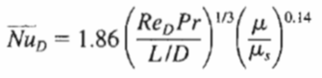

subjected to 0.6 ≤ Pr ≤ 5 & 0.0044 ≤ (μ/μs) ≤ 9.75

The Reynolds no. and Prandtl number have been calculated as follows.

|  |  |  |  |
| --- | --- | --- | --- |
| Reynold No, Saturated Vapour | 77.950492 | Prandtl No, Saturated Vapour | 1.250561045 |
| Reynold No, Room Temperature Vapour | 4.847582 | Prandtl No, Room Temperature Vapour | 0.663539909 |

`

As can be seen the conditions of laminar flow and combined entry length has been satisfied so the Sieder and Tate correlation can be used.

**4. RESULTS:**

|  |  |  |
| --- | --- | --- |
| Total Heat-in-leak to the vessel | 25.9104 | W |
| Heat-in-leak to liquid helium | 0.3495 | W |
| Evaporation rate corresponding to Total Heat-in-leak | 859.64 | l/day |
| Evaporation rate corresponding to actual Heat-in-leak | 11.59 | l/day |
| Reduction in the Helium evaporation rate due to insulation system | 848.05 | l/day |

Thus it can be seen that the utilization of the cold enthalpy of the vapour along with the insulation system has reduced the evaporation from evaporating the entire liquid from the vessel to 2.318% per day.

**5. List of References**

|  |  |  |
| --- | --- | --- |
| **Sr. No.** | **Documents** | **Reference** |
| 01 | Incropera, Dewitt, Bergman, Lavine, ‘Fundamentals of heat and mass transfer’ ,Sixth edition, John wiley and sons, p.p. 513 | [1] |

**Annexure : Drawing for the inner and outer vessel of the helium dewar**

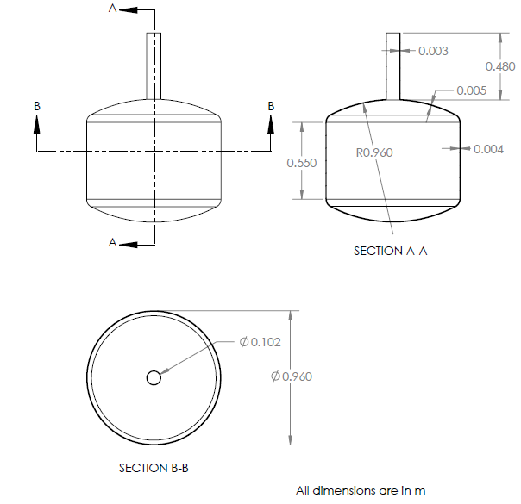

**Inner vessel**

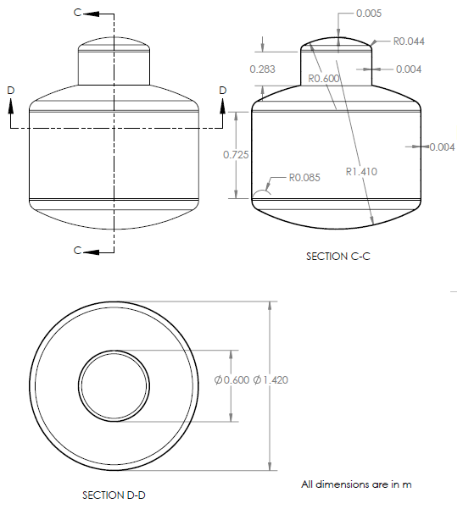

**Outer vessel**